1. Based on the above two types of Execution, the LINQ operators are divided into 2 categories. They are as follows:

* Deferred or Lazy Operators: These Query Operators are used for Deferred Execution. For example – **Select, SelectMany, Where, Take, Skip**, etc. belongs to the Deferred or Lazy Operators Category.
* Immediate or Greedy Operators: These Query Operators are used for Immediate Execution. For example – **Count, Average, Min, Max, First, Last, ToArray, ToList**, etc. belongs to the Immediate or Greedy Operators category.

1. LINQ Deferred Execution using C#:

In this case, the LINQ Query is not executed at the point of its declaration. That means, when we write a LINQ query, it doesn’t execute by itself. It executes only when we access the query results. So, here the execution of the query is deferred until the query variable is iterated over using for each loop. Let us understand this with an example. The example below is self-explained. So, please go through the comment lines.

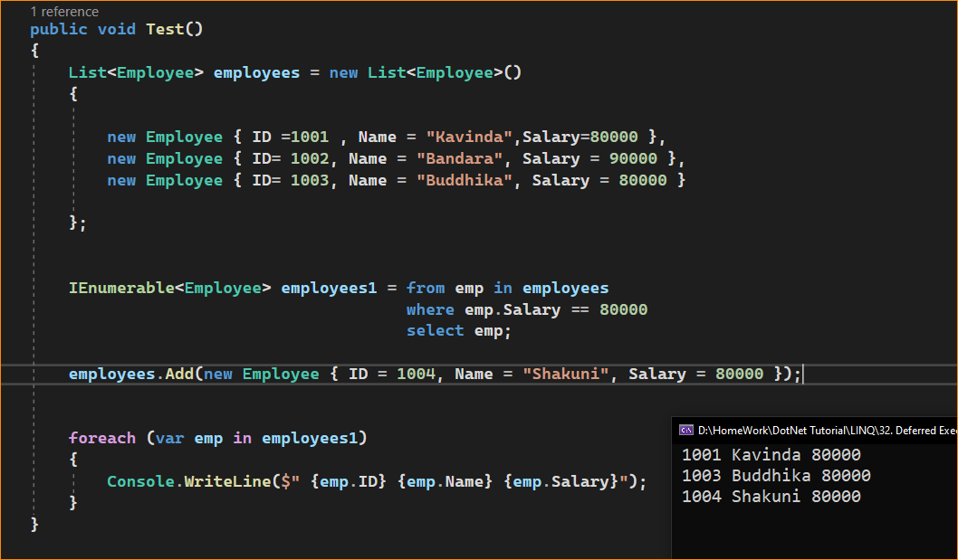

1. Advantages of LINQ Deferred Execution in C#:

We will get the following advantages

* It avoids unnecessary query execution which improves the performance of the application.
* The Query creation and the Query execution are decoupled which provides us the flexibility to create the query in several steps.
* A LINQ deferred execution query is always re-evaluated when we re-enumerate. As a result, we always get updated data.

1. LINQ Immediate Execution using C#

In the case of Immediate Execution, the LINQ query is executed at the point of its declaration. So, it forces the query to execute and gets the result immediately. Let us see an example for a better understanding. The following example is self-explained. So, please go through the comment lines.

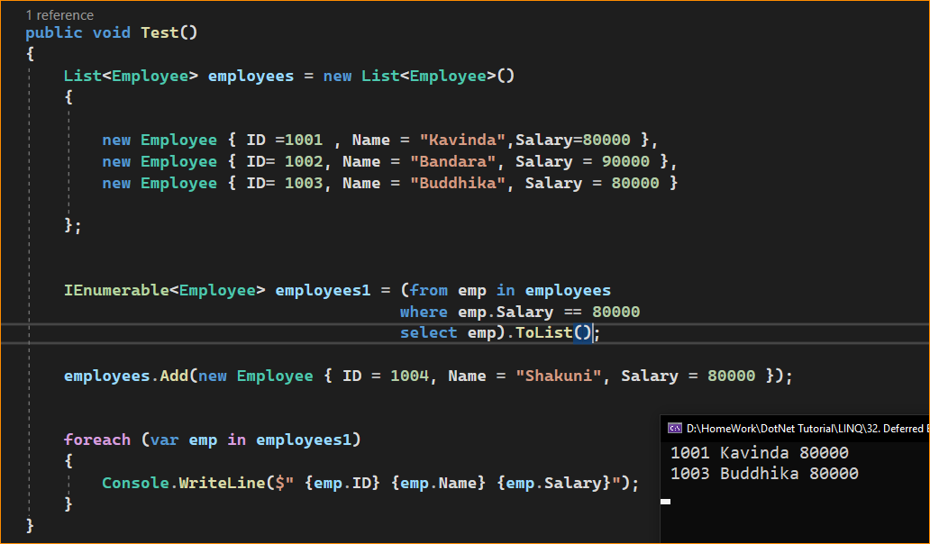

* In the following statement, the LINQ Query is executed immediately as we are
* Using the ToList() method which is a greedy operator which forces the query
* to be executed immediately.
* Adding a new employee with Salary = 80000 to the collection listEmployees
* will not have any effect on the result as the query is already executed